1. **NOTE**: There may be cases in your application, where you want a different service instance. You can do that.
2. **NOTE**: In the second last lecture, we saw a problem where we were adding a new account but that was not being displayed on the screen but here was no error in the console.
   1. **Reason**:
   2. 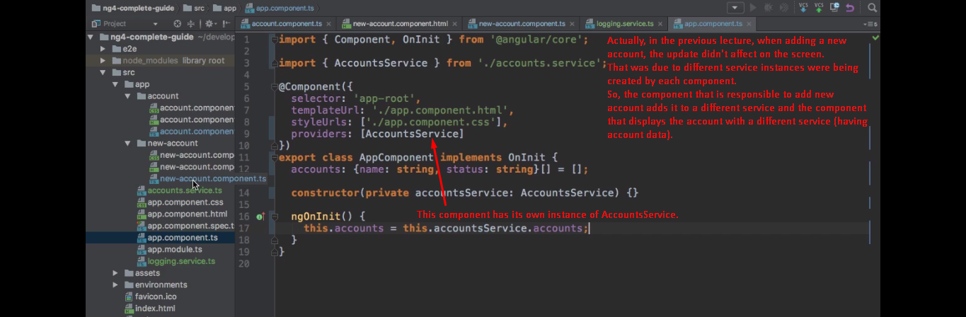
   3. 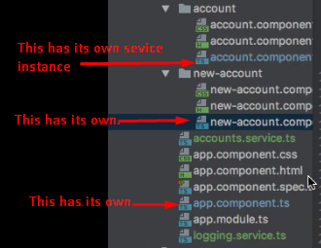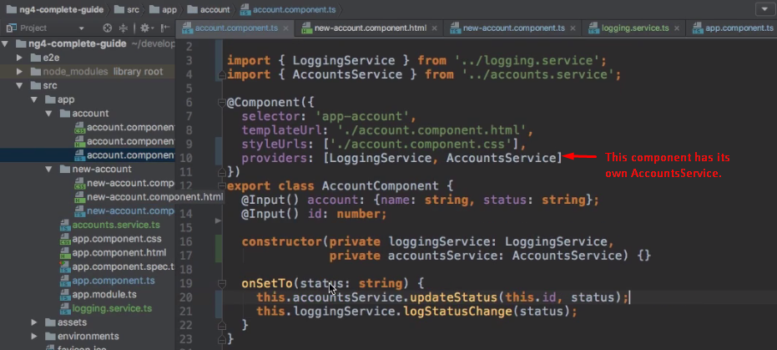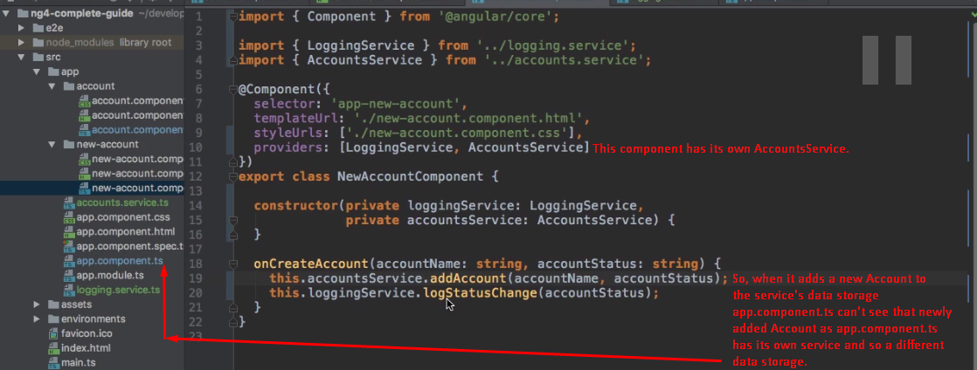
3. 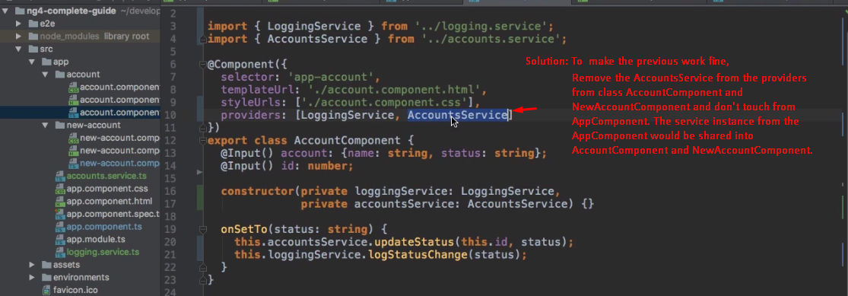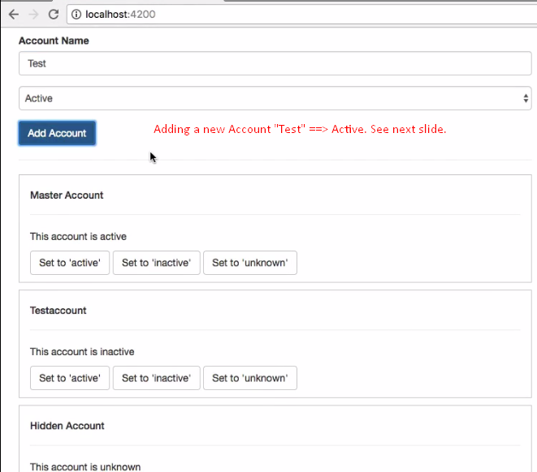
4. 